

**Graphic Arts Institute**

**Depertment of Computer Science and Technology**

Project Report

On

“Lost and Found System”

**Submitted to:**

Shajib Bhawal

Chief Instructor

**Submitted by:**

Mitab Sany

Roll: 452056

**Lost and Found System**

**Introduction**

The Lost and Found System is a comprehensive web-based application designed to streamline the process of reporting and tracking lost items within the campus community. This system serves as a centralized hub for managing lost and found items, enhancing the overall user experience and promoting community engagement.

**Features**

**Reporting Lost Items**

* + **User-Friendly Interface:** The system features an intuitive form that allows users to report lost items efficiently. The form captures essential details, including the item name and a detailed description.
  + **Client-Side Validation:** To ensure data accuracy, basic client-side validation has been implemented. Users receive immediate feedback if crucial information is missing before submitting the form.
  + **Clear Submission Process:** Upon successful submission, users are notified of the completion, providing a transparent and straightforward reporting process.

**Found Items Section**

* + **Dynamic Display:** The "Found Items" section dynamically displays cards for each found item. These cards present relevant information such as the item name, description, and the option to claim the item.
  + **Responsive Design:** Tailwind CSS has been utilized to ensure a responsive and visually appealing layout, allowing users to access the system seamlessly on various devices.
  + **Claim Item Functionality:** Users can claim a found item directly through the system. Once an item is claimed, the card is visually marked, and the "Claim Item" button is disabled to prevent duplicate claims.

**Claiming Items**

* + · **Visual Feedback:** The system provides immediate visual feedback when a user successfully claims a found item. This includes updating the appearance of the card and disabling the "Claim Item" button.
  + · **Preventing Duplicate Claims:** To maintain fairness and accuracy, the system is designed to prevent users from claiming an item multiple times.

**Screenshots**

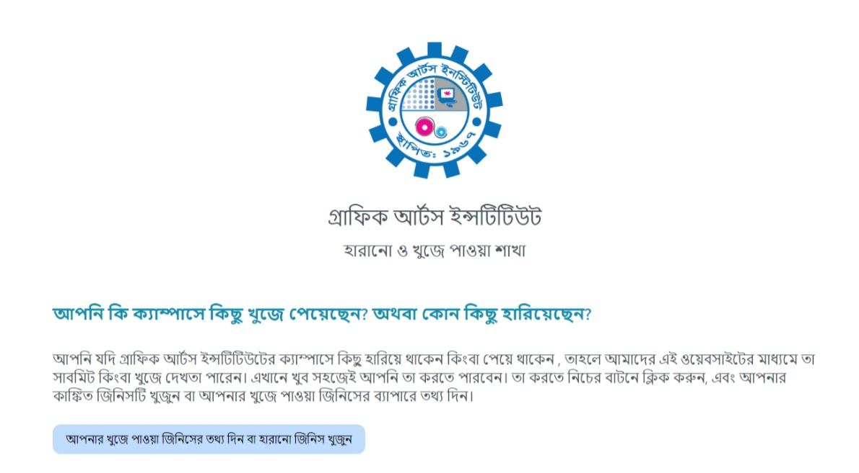

*Caption: Users can easily report a lost item by providing detailed information in the intuitive form.*

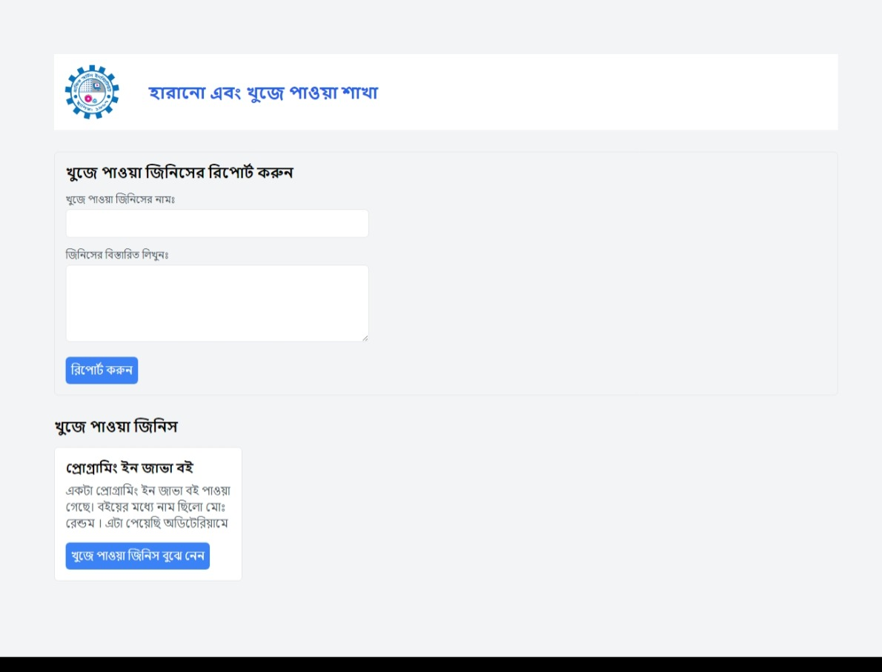

*Caption: The "Found Items" section displays dynamically generated cards with pertinent details about items found by other users.*

**Implementation**

**Frontend Technologies:**

* + HTML, CSS, JavaScript
  + Tailwind CSS for styling

**Client-Side Validation:**

* + · Implemented robust client-side validation to ensure data integrity and guide users through the reporting process.

**Dynamic UI:**

* + · Utilized JavaScript to dynamically update the UI, providing a seamless and interactive experience for users.

**Responsive Design:**

* + · Tailwind CSS was employed to create a responsive design, optimizing the system for a wide range of devices.

**Future Improvements**

**Server-Side Processing:**

* + Future development will focus on implementing server-side processing to handle form submissions, store data securely, and manage item claims.

**User Authentication:**

* + Enhancing security measures through user authentication will be a key aspect of future development, providing a more personalized and secure environment.

**Notifications:**

* + Implementing a notification system to alert users about the status of their reported items and claimed items.

**Conclusion**

The Lost and Found System represents a significant step forward in managing lost and found items on campus. The system's current implementation focuses on providing users with a seamless reporting and claiming experience. As the system evolves, incorporating server-side processing, user authentication, and additional features will contribute to its overall effectiveness and user satisfaction.